CHHATRAPATI SHAHU JI MAHARAJ UNIVERSITY, KANPUR

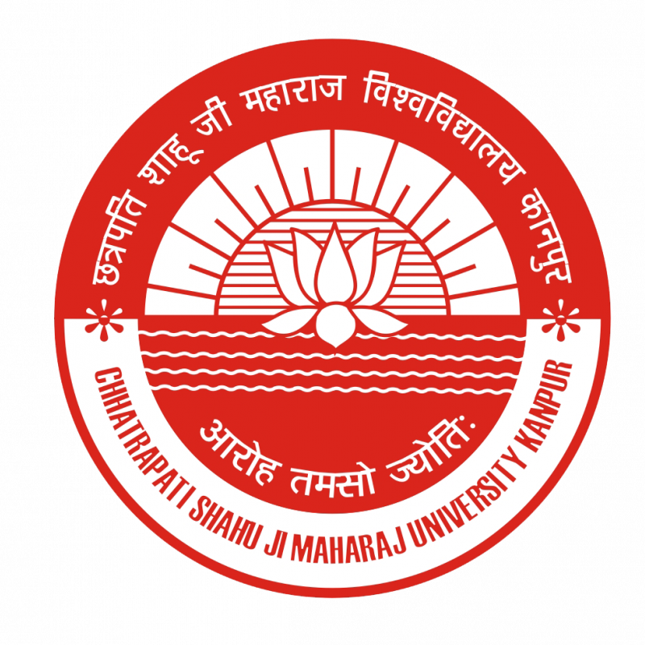

STRATEGIC PLAN
(2017-2022)

ABOUT THE UNIVERSITY
The Chhatrapati Shahu Ji Maharaj University, Kanpur (Formerly Kanpur University, Kanpur) was established in the year 1966. The University has not looked back since then and has become a hall mark of higher education in the State catering to more than 1200000 students pursuing graduate, post-graduate and PhD degrees in all subjects including arts, commerce, science, education, law, agriculture, medicine, Ayurvedic and Unani education, agriculture, engineering and technology, business management, life science, to the students of about seven hundred colleges present in seven districts.
During the five decades of its existence, the University has established as center of excellence in teaching, training and research.
Chhatrapati Shahu Ji Maharaj University (CSJMU) Kanpur (formerly Kanpur University) is a symbol of eminence and academic excellence, which can be approached and availed by the citizens of Kanpur and neighboring regions.

VISION
To enlighten and empower humanity by nurturing future leaders and change agents for universal development and societal transformation.

MISSION
To work towards sustainable excellence in global standards of academia, technology-centric learning, robust research ecosystem, institutional distinctiveness and harmonious social diversity.

STRATEGIC PLANNING PROCESS
The sole aim of the University is to work towards sustainable excellence in global standards of academia, technology-centric learning, robust research ecosystem, institutional distinctiveness, and harmonious social diversity. The University endeavors to enlighten and empower humanity by nurturing future leaders and change agents for universal development and societal transformation. In order to fulfill its Vision and Mission, the University has developed its institutional strategic plan. The University Strategic Plan sets out a framework of priorities for the University, its divisions and departments. The University has updated its Values, Vision, Mission, Objectives, and Strategic Plan to reaffirm its commitment to excellence. The plan has been formed after exhaustive brain-storming with the various heads and the authorities of the university. The strategic plan aims at coalescing its various schools and administrative units, in order to navigate them towards holistic and sustainable development.

STRATEGIC GOALS
The University’s commitment to its vision and mission is reflected by value based conduct and behaviors of faculty, staff and students in all areas of performance. Values serve as the guiding philosophy in all walks of University life. It is a prerequisite to have strategic plan to enhance the holistic development of the University and become a leading centre contributing to the intellectual, social, cultural and economic development as per the vision and mission. The Strategic goals of the University are dynamically revised. In the coming five years (2017-22), we envisage the following major strategic goals:
- Global Standards of Academia – Continuously delivering outstanding quality in all areas of performances by fostering intellectual growth.
- Technology-centric learning- improve the ICT enabled services
- Robust research ecosystem- The breadth of our research and the connections between disciplines drive advancement in knowledge, understanding, innovation and creativity.
- Institutional distinctiveness- Having an unending quest for discovering new ideas in all areas of performance, enriched by diversity in thoughts, actions and leadership.
- Harmonious social diversity- Having concern for nature, environment and resource utilization for long lasting, safe and better future

1. GLOBAL STANDARDS OF ACADEMIA
Through a commitment to the personal education of each student, we will provide a quality of education and experience which equips students with the values, skills and intellectual discipline that will enable them to make a positive contribution to society.

Objectives
- To develop customized E-Learning portal for students to address rapidly changing learning scenario.
- To developing Augmented Learning Programs for Online Education
- To achieve excellence in E-Content development and broadcasting
- To start innovative academic programs at UG & PG level
- To benchmark reputed national and international Higher Education Institutes.
- Faculty Competency Building in areas of New Age Technologies & Research
- To build digital capacities of each student enrolled in the campus to improve employability
- To revise the curriculum as per the global standards
- To Strengthen collaboration with Industry in Research, Consultancy, Training & Internships
- Global Initiatives & Collaborations with Foreign Universities
- To enhance the diversity by recruitment and retention of faculty, staff, and administrators.
- Enhanced Community Engagement through Social Outreach Programs
- Focus on Skill Development Programs to make students ready for global job market

Strategy
- Encourage teachers and students to access more ICT/E-learning tools
- Review/restructure the existing academic programs/syllabi as per the changing environment or industry requirement. Thus making the curricula more innovative and distinctive
- Take initiatives for the enhanced student engagement in the academic activities
- Review/restructure the existing academic programs/syllabi as per the changing environment or industry requirement. Thus making the curricula more innovative and distinctive.
- Take initiatives for the enhanced student engagement in the academic activities
- Improve the teaching/learning environment
- Implement outcome based education
- Introduce choice based credit system
- Encourage the students to undergo online certification courses like NPTEL.
- Promote and support university readiness to adopt present and future technological development.
- Use of blended teaching methodology involving traditional, interactive, and ICT enabled pedagogical techniques.
- Encourage faculty and students to acquaint with ICT enabled teaching learning processes.
- Develop technology enabled activity tools to make understand the concepts of core courses
- Identify the changing trends in the global education sector and implementing the required.
- Recruit diversified faculty as per the norms of the university fulfilling the requirement in all domains of the department.
- Perform training need analysis for staff and faculty and depute for training.

2. TECHNOLOGY-CENTRIC LEARNING
Technology resources, which include facilities, equipment, and other assets, support student learning programs and services and improve institutional effectiveness. Technology resource planning is integrated with institutional planning.

Objective
- To enhance the library resources
- To improve the ICT enabled services
- To innovate and adopt technology enabled pedagogy

Strategy
- Curriculum Harmonization with National and International Patterns.
- Continue to enhance library resources and infrastructure.
- Increase the subscription for online journals and databases.
- Provide state-of-the-art computing facilities along with other ICT devices for enhancing TLP.
- Provide sufficient bandwidth and uninterrupted connectivity for content delivery.
- Utilize innovative teaching tools and new pedagogies to engage students more effectively through ICT, MOOCs/SWAYAM and Blended Learning etc.
- Thrust on E-Content development and excellence in digital delivery of content
- Increased focus on achieving program and course outcomes, Questions Assessments pattern, Practical learning, Internships, Assessments
- Diversifying faculty and enhancing excellence & Specializations through Faculty Development Programs, Management Development Programs, Industry Trainings etc.

3. ROBUST RESEARCH ECOSYSTEM
The university is committed to high quality research and innovation. In order to facilitate research activities, the university has developed a well-drafted research policy to guide, encourage, fund, support and monitor core and interdisciplinary research. University and individuals are encouraged to achieve and sustain research excellence.

Objectives
- To establish centers of excellence in emerging areas to promote research.
- To improve research quality, productivity, and impact
- To promote multidisciplinary research in new, emerging and thrust areas.
- To create environment and facilities for interdisciplinary research
- Building a corpus to provide financial support to research scholars for publications and conferences
- Inspiring and supporting the faculty members towards quality publications and participation in more FDP’s and workshops in the near future
- Emphasis on Entrepreneurship Incubators and Patent Commercialization

Strategy
- Identify core areas of potential research.
- Identify institutions and industries for collaborative research.
- Establish centers of excellence in emerging areas of potential research.
- Equip research centers with state-of-the-art research facilities to encourage students and faculty to carry out their research.
- Encourage faculty to publish papers in high quality peer reviewed journals.
- Encourage faculty to submit project proposals to funding agencies.
- Establish relation with various research organizations and institutions to collaborate in research activities
- Focused guidance and networking of students to disseminate knowledge and support to participate in National and International level competitions
- Strengthen research capacities and promote student participation in research activities, incubations, start-ups.
- Establish novel initiatives and develop on-going projects to attract and retain high performing research faculty.

4. INSTITUTIONAL DISTINCTIVENESS
The university shall promote collaborations in research, teaching and employment at national as well as international levels. The partnership with different organizations will contribute towards achieving the objectives of the university.

Objectives
- To transform and become an aspirational destination for students and faculty
- To identify opportunities and create facilities for attracting foreign students, researcher and teachers to the University
- To identify opportunities for the students and teachers of the University to get exposed to international teaching and research.
- To strengthen industry interaction
- To promote a culture of Innovation and Entrepreneurship.

Strategy
- Interact with the industry experts at almost all levels.
- The training and placement cell of the university will take care in placing the students at their desired companies.
- Bring the companies to the campus for placements; arrange MOU’s and Guest Lectures etc. The feedback from the industry experts is considered for the improvement of the quality in all aspects.
- Exploring the possibilities of collaborations with Companies for training and employment opportunities for students.
- Entering into collaborative arrangements with reputed academic university, research institutes and industry forums for creating opportunities for students and faculty.
- Forming strategic alliances with prominent universities / eminent professors for Virtual Lectures.
- Introduce industrial participation with academics.
- Establishing collaborations with central and state government ministry and agencies, and other leading universities within the country.
- Build a co-learning innovation hub that is well connected to similar hubs locally, nationally, and internationally.
- Create an innovation fund for selective early-stage investment.
- Impart industry ready skills to students through industry interactions.
- Invite eminent personalities from Government Organizations, Industry Corporate to the institution at various occasions.
- Encourage faculty to prepare project proposals and submit for funding agencies.
- Encourage faculty and students towards innovation and entrepreneurship.
- Expanding career opportunities for skill development, training and job placement to benefit students.
- Strengthening alumni relations, Alumni interactions, Alumni referral schemes, Incubation& Entrepreneurship.
- Student driven, alumni and industry mentored, faculty guided initiative to establish an ecosystem for students, alumni, faculty and staff to nurture Projects (patents, products, publications), Research, Innovation (Ideation, incubation), Design and Entrepreneurship competence
- Promote an ongoing program of education, including research, innovation, and entrepreneurial training, that supports staff and students.
- Build a co-learning innovation hub that is well connected to similar hubs locally, nationally, and internationally.
- Create an innovation fund for selective early-stage investment

5. HARMONIOUS SOCIAL DIVERSITY
Harmony within diversity simply means living together peacefully irrespective of race, culture and religion. Diversity is what makes this nation progress and prosper. It fosters intellectual development, stimulates growth and enhances the spirit of entrepreneurship. The University upholds the value of sustainability in all its endeavors. It will work towards achieving sustainability by creating awareness, orienting courses, instituting training and facilitating research to imbue the spirit of sustainability in individuals associated with it.

Objectives
- To expand transformational education experiences through community service, global outreach, and innovative study-abroad opportunities.
- To strengthen alumni interaction
- To strengthen community interaction
- To promote environmental awareness and sustainability

Strategy
- Engage students in solving social problems face by the local community.
- Establishing relationship with local and regional bodies to assess their requirements and issues.
- Encouraging faculty and students to undertake socially relevant projects in their academic pursuits.
- Collaborate with NGOs and social entrepreneurs by signing MoU to expand innovations leading to social entrepreneurship.
- Provide solutions to societal problems through research and and innovation
- Engaging local community for social development & entrepreneurship.
- Enhance university support, encouragement and participation for student-led socially relevant activities.
- Skill development Programs for local community.
- Strengthening our contribution to national and global policymaking.
- Promotion of Educational Activities for all
- Setting up centers to provide education for weaker sections of society
- Popularizing, implementing and monitoring University green policy and green calendar.
- Promoting healthy environment friendly practices by making a vehicle free zone in the campus.
- Developing infrastructure and systems in accordance with prevailing energy efficiency/ green Standards
- Instituting electives on sustainable development practices.

